Patient Monitoring device

Siddiqi Mohammad Ashrafuzzaman  
*Electrical engineering*   
University of applied sciences Hamm Lippsdadt Lippsdadt,Germany  
*mohammad-ashrafuzzaman.siddiqi@stud.hshl.de*

*Abstract*—Doctors and other health professionals must keep track of their patients' vital signs. It provides excellent opportunity for the doctor to stay informed about a patient's present state and intervene if necessary. The purpose of this study is to suggest a health-care system that allows clinicians to keep a careful eye on their patients' vital signs. This will increase patient–doctor communication by allowing patients' data to be more easily accessible.

Keywords—Sensors, processor, patient, doctor

# Introduction

This medical equipment is designed to be utilized in a hospital and is available at every patient bed. Its purpose is to provide a fast summary of patient vitals to the doctor at any time.

Doctors can't always keep an eye on patients in multispecialty hospitals, which contain a lot of wards and a lot of patients in each one. Doctors set up time slots for this, and each ward is visited after a set amount of time has passed. Patients may, however, have problems in the periods between these time spans. This is inconvenient for patients, and hospital administrators may feel powerless in the face of the issue. The patient monitoring device provides a solution for this it continuously provides information to doctors.

# CONCEPT

## Elements of the system

Doctor, Nurse and other medical experts

Patient

Device: Monitor, Pic Microcontroller, LM35 temperature sensor, CO sensor, heartbeat sensor, ECG sensor, storage, speaker, battery pack.



Fig 1.

## 

Fig 1: system diagram

Both hardware and software integration are required for the proposed approach to work. The premise is simple: sensors read vitals, which are then sent to a processor, which displays the information for health workers to use. In this method, microcontrollers, a screen, and other health sensors are used.

Fig 2: state machine diagram

Our system begins in the vitals reading state, where vitals are read by various sensors such as the ecg sensor, the lm35, and the pressure sensor. After vitals are read, we send them to the microcontroller, which processes the vitals and displays the results. The microcontroller also consistently checks the parameter to see if it exceeds the constraints set, if it does, it transitions into the alarm state, which can only be deactivated by an actor pressing the stop button.

## .

# Concept design

The design approach involves various Sysml, Uml structures listed below along with a detailed hardware specification

## Requirements

*Functional*

* *The system shall operate in Real time*
* *The system shall Display patient information and vitals*
* *The system shall activate alarms in the right scenario*
* *The system shall regularly collect vitals from the patient*
* *The system shall process vitals collected and detect abnormal readings*

*Non Functional*

* *Availability: system should be operational 24/7*
* *Reliable: As a medical system it should be fully functioning*
* *Design: screen should be 15 inches with touch screen capabilities and button functions*
* *Performance: the system should update the vitals data every second*

## MODELS

### Use case

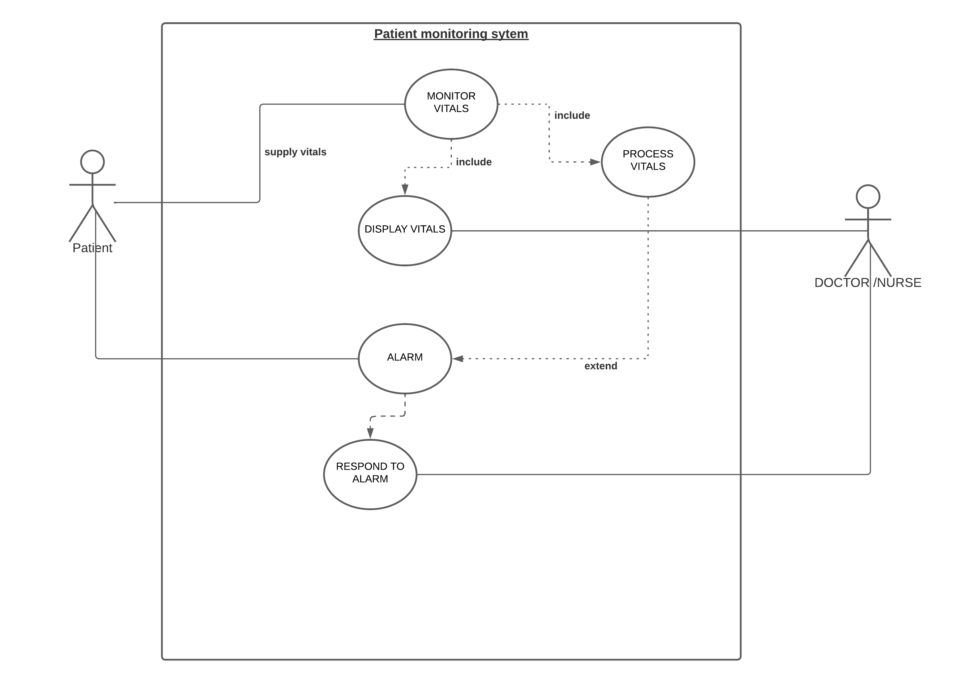

Fig 3: Use case

The device is used to monitor vitals, display vitals, process vitals and send alarm, this functionality is provided as a result of input generated from the patient vitals. The doctor or nurse can act pertaining the stopping of

### Activity diagram

This diagram depicts the data flow from sensors to microcontroller and then to the display. It also depicts the alarm conditions and what happens if they are met or not.

Fig 4. Activity diagram

## Hardware specification

### MSP430 Microcontroller

MSP430 Microcontrollers (MCUs) from Texas Instruments (TI) are 16-bit, RISC-based, mixed-signal processors designed specifically for ultra-low-power (ULP). It is based on Von Neuman architecture.MSP430 MCUs have the right mix of intelligent peripherals, ease of use, low cost, and lowest power consumption for thousands of applications. TI offers robust design support for theMSP430 MCU platform along with technical Page documents, training, tools, and software to help designers develop products and release them to market faster.[1]

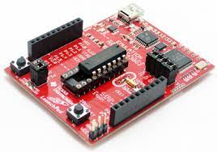

Fig 5. MSP430 microcontroller

### Blood Pressure

The body parameter, Blood Pressure (B.P.) is then given to the pressure sensor. The signal from the pressure sensor is then conditioned within op-amp circuit or by an instrumentation amplifier before data conversion by an analog-to-digital converter (ADC). The systolic pressure, diastolic pressure and pulse rate are then calculated in the digital domain using a method appropriate for the type of monitor and sensor utilized. The resulting systolic, diastolic and pulse-rate measurements are then displayed on a liquid-crystal display (LCD). The fig below shows the blood pressure sensor employed in the project.[1]

Fig 6. Mps-2107

### Heart Rate

The body parameter, heart rate is evaluated with the help of a principle known as photoplethysmography (PPG). It makes use of transmittance PPG which helps in designing a pulse sensor. It further leads to the evaluation of appropriate heart beats rates corresponding to the obtained input heart beats. The heartbeat sensor circuit uses a reflective IR sensor with necessary instrumentation circuit to illustrate the principle of photoplethysmography as a noninvasive technique for measuring heart rate.

The sensor used in this project is TCRT1000, which is a reflective optical sensor with both the infrared light emitter and phototransistor placed side by side and are enclosed inside a leaded package so that there is minimum effect of surrounding visible light.

A finger is illuminated by an IR light-emitting diode. More or less light is absorbed, depending on the tissue blood volume. Consequently, the reflected light intensity varies with the pulsing of the blood with heartbeat. A plot for this variation against time is referred to be a photoplethysmography or PPG signal. Fig7 shown below shows the external biasing circuit for the TCRT1000 sensor.[1]

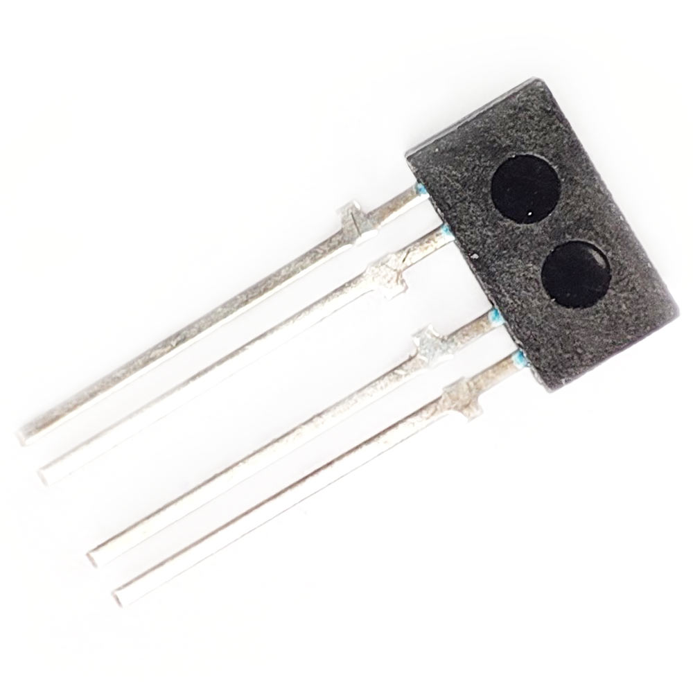

Fig 7. TCTR1000

### Electrocardiogram (ECG)

The electrocardiogram (ECG or EKG) is a diagnostic

tool that is routinely used to assess the electrical and muscular functions of the heart.

The Electrocardiogram Sensor (ECG) has grown to be

one of the most used medical tests in modern

medicine. Its utility in the diagnosis of a myriad of cardiac

pathologies ranging from myocardial schema and infraction to syncope and palpitations has been invaluable to clinicians[1].

Fig 8. ECG sensor

### Monitor

A 16inch monitor will be required to ensure that the system can display vitals sign

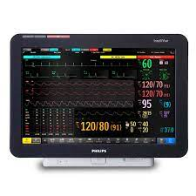

Fig 9. Monitor

### ADC

Analog to Digital conversion is done using Dallas Semiconductor’s MAX197, a 12 Bit (8+4) ADC with8 bit data bus and 8 analog input channels that are in-dependently software programmable for a variety of ranges.

### Speaker

GE Critikon DinaMap Pro Series Patient Monitor Speaker Assembly.

Fig 10. Ge critikon dina map speaker

### Temperature sensor

Temperature sensing can be done either through direct contact with the heating source, or remotely, without direct contact with the source using radiated energy instead. There are a wide variety of temperature sensors on the market today, including Thermocouples, Resistance There are a wide variety of temperature sensors ICs that are available to simplify the broadest possible range of temperature monitoring challenges.

These silicon temperature sensors differ significantly from the above-mentioned types in a couple of important ways. The first is operating temperature range. A temperature sensor IC can operate over the nominal temperature range of -55°C to +150°C. The second major difference is functionality. A silicon temperature sensor is an integrated circuit and can therefore include extensive signal processing circuitry within the same package as the sensor. There is no need to add compensation circuits for temperature sensor IC. Some of these are analogue circuits with either voltage or current output Digital output sensor usually contains a temperature sensor, analog-to-digital converter (ADC), a two-wire digital interface and registers for controlling the IC’s operation. Temperature is continuously measured and can be read at any time. If desired, the host processor can instruct the sensor to monitor temperature and take an output pin high (or low) if temperature exceeds a programmed limit. Lower threshold temperature can also be programmed, and the host can be notified when temperature has dropped below this threshold. Thus, digital output sensor can be used for reliable temperature monitoring in microprocessor-based systems.

## Critical parts fail safe

The plan is to avoid a total failure of the system by use of redundant architecture. We plan to use two Arduino to ensure that whenever vitals are process, they are accurate and precise. This will be done by having a primary Arduino which correlates readings and results with the secondary Arduino.

Fig 11. State machine hardware redundancy

For the sensors we plan to use a time redundancy, checking the readings milli seconds apart and accessing the difference between values to ensure the sensors are still given an accurate reading of the vitals.

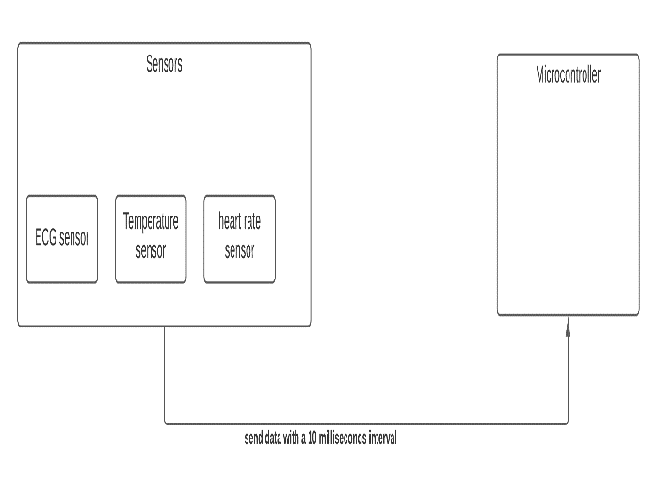

Fig 12. Time redundancy block diagram

## User Interface

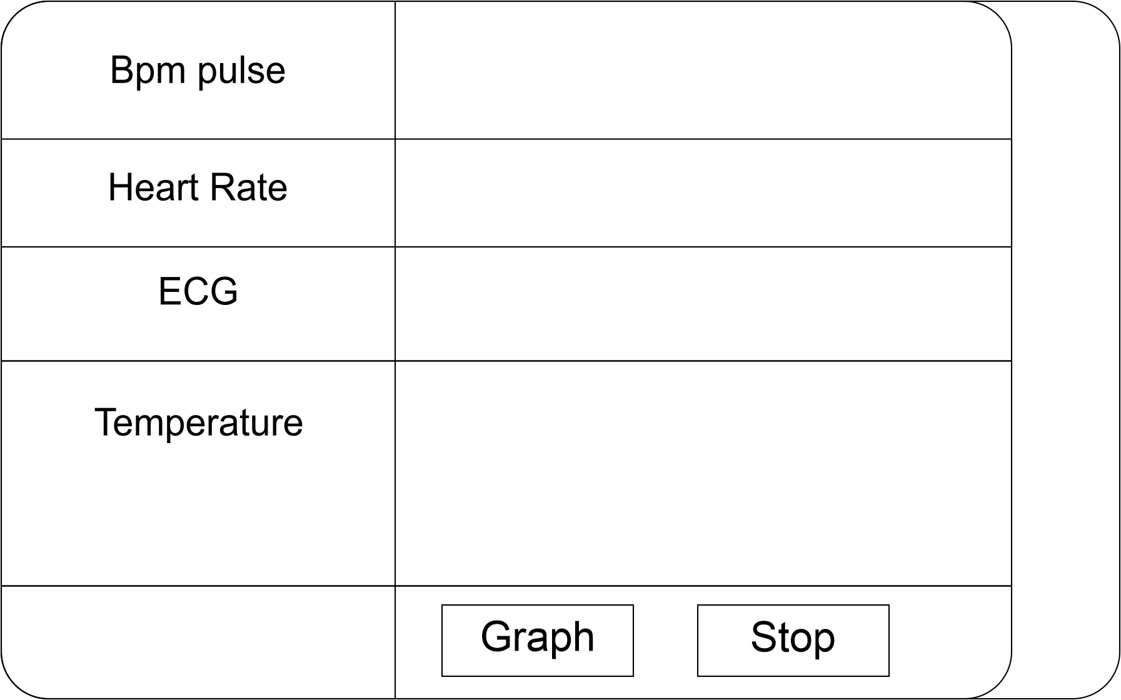

The user interface compromises a visual metric for the blood pressure, temperature, ECG, heart rate, it also includes a stop button for an actor to press in case of alarm. It is a simplistic design with the focus on usability and ease of use.

### User Interaction state chart

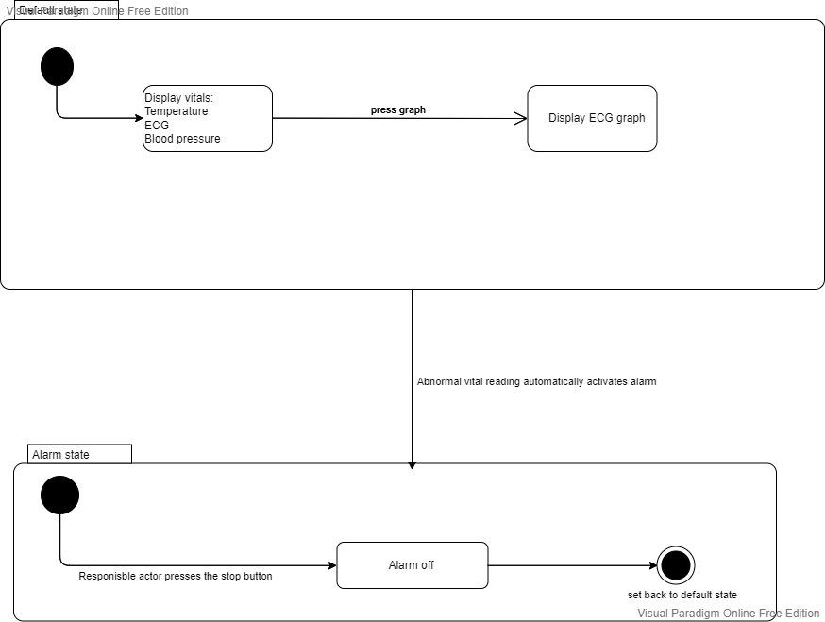

Fig 13. User interaction state chart

At the default level the system will be display the vitals continuously, a press of the graph button will display the ECG graph. If the vitals reading is abnormal, it immediately transitions to the alarm state where only a press of the stop button can return it to the system default state.

# Discussion

The "Patient Monitoring System" is the proposed system described in this paper. This paper discusses the techniques that can be used to provide the necessary information about any patient's physiological conditions by taking body parameters into account. It gives an adequate and relatively simple solution to the problem that doctors face with having multiple patients and no easy way to access their data at any required time. Models have been implored to show the behavior of the proposed system. The first block diagram (fig 1) shows the general process of the system, which is sensors taking vitals and sending them to the micro controller, which processes the data and displays the vitals or activates the alarm. This design is intended to solve the doctor’s problem accurately. We also use redundancy to make sure that the sensors and microcontroller do not give out false information, as health-related devices are critical systems and need to be safe guarded against faults and errors. At the start, we did not include redundancy or even an alarm, but these functionalities were added after discussion in the interactive classes to make our overall architecture a more interactive and complete one. The alarm function enables the device to interact with the doctor and other health workers clearly and precisely. The doctor can also interact with the device by pressing the stop button.

# conclusion

### Overview

The attempt was to design a device that not only monitors patient vitals but acts as an alarm system in case of abnormal vitals. The work presented reveals that a patient monitoring system is achievable to transmit and receive data for immediate action to be taken according to the simulation results. This system provides an effective solution to upgrade the existing health system by using different kinds of sensors mounted on a single system. Besides, this system is based on a simplistic design. The system consists of msp430 support, and one can set values according to the requirements of the patient under consideration. This system will be unique for multiple applications as the parameters can be modified. This system is convenient and efficient in nature and will improve interaction between patient and doctor, ultimately avoiding unexpected tragedy. The system also puts interactive design at its forefront, designing a system that’s easy to use and understand. Models like state charts show how users interact with this system. They also show different conditions that have been set, like the alarm condition, which is activated by default if certain constraints are exceeded. This work is an accurate depiction of the intended realization for the device, also stating clearly all the intended hardware components. The main purpose of this device is to provide urgent treatment to patients who need it immediately, to make the doctor aware of the condition immediately and act immediately. The system has to be reliable and functional at all times. It also has to provide accurate readings. This was ensured by time redundancy for the sensors and hardware redundancy for the mps430 micro controller.

### Future direction

* We would like to add more parameters in future iteration of this design, like sp02 it will enable the doctor to have better array of data to analyze the patient situation.
* We would like to create a user interface where doctor will also see patient data.
* We would also like to add a cloud functionality were data from several monitors will be sent and accessible by the doctor remotely
* Wireless sensors are also a possibility we are looking at in the future

he electrocardiogram (ECG or EKG) is a diagnostic

tool that is routinely used to assess the electrical and muscu-

lar functions of the heart.

The Electrocardiogram Sensor (ECG) has grown to be

one of the most commonly used medical tests in modern

medicine. Its utility in the diagnosis of a myriad of cardiac

pathologies ranging from myocardial schema and infraction

to syncope and palpitations has been invaluable to clinicians.

he electrocardiogram (ECG or EKG) is a diagnostic

tool that is routinely used to assess the electrical and muscu-

lar functions of the heart.

The Electrocardiogram Sensor (ECG) has grown to be

one of the most commonly used medical tests in modern

medicine. Its utility in the diagnosis of a myriad of cardiac

pathologies ranging from myocardial schema and infraction

to syncope and palpitations has been invaluable

##### Acknowledgment

I would like to acknowledge my classmates and professors that gave me feedback to improve my product in an iterative manner.

##### References

1. Ms Aishwarya D. Gavali et al. Int. Journal of Engineering Research and Application www.ijera.com ISSN : 2248-9622, Vol. 6, Issue 12, ( Part -2) December 2016, pp.26-29J. Clerk Maxwell, A Treatise on Electricity and Magnetism, 3rd ed., vol. 2. Oxford: Clarendon, 1892, pp.68–73.